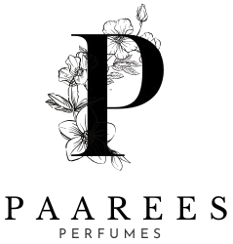

PAAREES PERFUME COLLECTION AND DESCRIPTION

PAAREES PERFUME
The Essence Of Elegance
Born from the heart of luxury, Paarees Perfume celebrates timeless beauty and sophistication. Each fragrance captures a unique story — from floral dreams to golden warmth — made for those who believe that scent is not just a touch, but a signature of personality.
Contents
AMBER LUXE 3
Fragrance Description: 3
Fragrance Notes: 3
Key Features: 3
About the Brand: 3
VELVET ROSE 4
Fragrance Description: 4
Fragrance Notes: 4
Key Features: 4
About the Brand: 4
MIDNIGHT BLOOM 5
Fragrance Description: 5
Fragrance Notes: 5
Key Features: 5
About the Brand: 5
GOLDEN AURA 6
Fragrance Description: 6
Fragrance Notes: 6
Key Features: 6
About the Brand: 6
MYSTIC NOIR 7
Fragrance Description: 7
Fragrance Notes: 7
Key Features: 7
About the Brand: 7
AZURE BLOOM 8
Fragrance Description: 8
Fragrance Notes: 8
Key Features: 8
About the Brand: 8
ROSE ELIXIR 9
Fragrance Description: 9
Fragrance Notes: 9
Key Features: 9
About the Brand: 9
CITRUS CHARM 10
Fragrance Description: 10
Fragrance Notes: 10
Key Features: 10
About the Brand: 10
MIDNIGHT OUD 11
Fragrance Description: 11
Fragrance Notes: 11
Key Features: 11
About the Brand: 11
GREEN SERENITY 12
Price: 12
Fragrance Description: 12
Fragrance Notes: 12
Key Features: 12
About the Brand: 12
CLOUD MIST 13
Fragrance Description: 13
Fragrance Notes: 13
Key Features: 13
About the Brand: 13
ROYAL ESSENCE 14
Fragrance Description: 14
Fragrance Notes: 14
Key Features: 14
About the Brand: 14
GOLDEN DESIRE 15
Fragrance Description: 15
Fragrance Notes: 15
Key Features: 15
About the Brand: 15
LOST CHERRY 16
Price: 16
Fragrance Description: 16
Fragrance Notes: 16
Key Features: 16
About the Brand: 16

Other Luxury Perfume Collection

AMBER LUXE
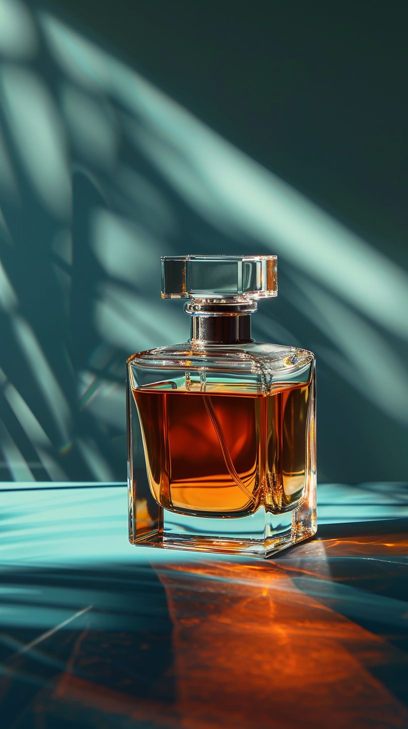
Price:
$120

Fragrance Description:
A rich oriental fragrance with notes of amber, sandalwood
, and vanilla, exuding timeless luxury.

Fragrance Notes:
Top Notes: Citrus, Floral Accents
Heart Notes: Jasmine, Peony, Amber
Base Notes: Musk, Vanilla, Sandalwood

Key Features:
• Elegant, long-lasting luxury scent
• Perfect for day or night wear
• Refined design and craftsmanship
• A blend of modern and classic sophistication

About the Brand:
Each luxury perfume represents artistry, emotion, and excellence — created for individuals who seek elegance, uniqueness, and unforgettable allure.
────────────────────────────

VELVET ROSE
Price:
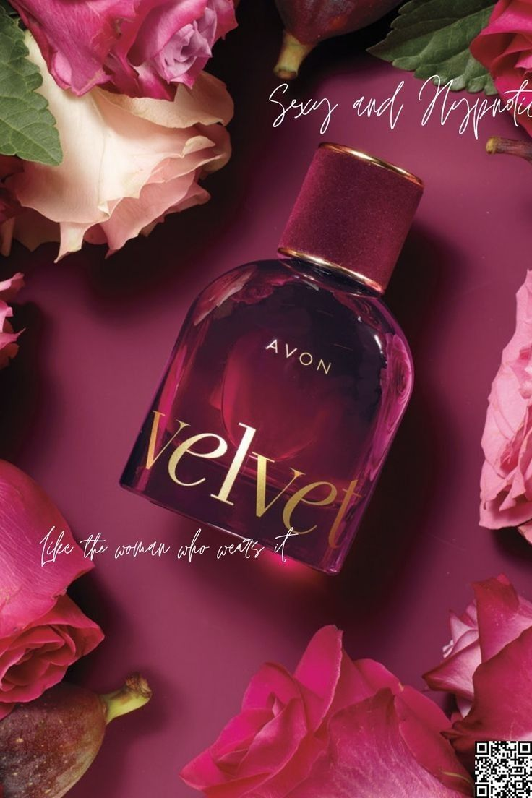
$95

Fragrance Description:
A romantic floral scent that captures the beauty of blooming roses with soft musk undertones.

Fragrance Notes:
Top Notes: Citrus, Floral Accents
Heart Notes: Jasmine, Peony, Amber
Base Notes: Musk, Vanilla, Sandalwood

Key Features:
• Elegant, long-lasting luxury scent
• Perfect for day or night wear
• Refined design and craftsmanship
• A blend of modern and classic sophistication

About the Brand:
Each luxury perfume represents artistry, emotion, and excellence — created for individuals who seek elegance, uniqueness, and unforgettable allure.
────────────────────────────

MIDNIGHT BLOOM
Price:
$110

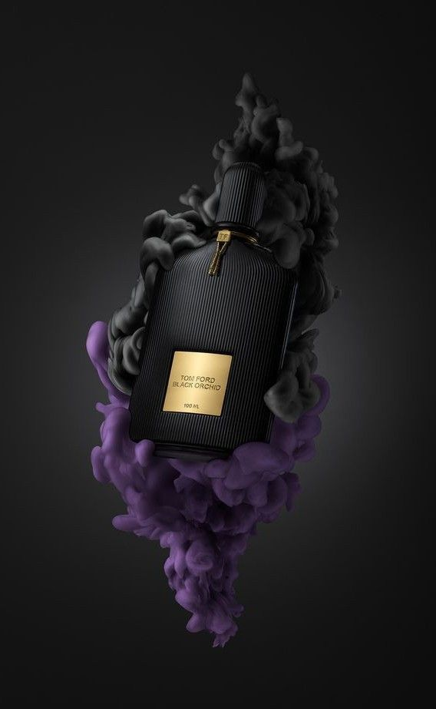
Fragrance Description:
Elegant and mysterious with jasmine, amber, and a hint of patchouli for evening sophistication.

Fragrance Notes:
Top Notes: Citrus, Floral Accents
Heart Notes: Jasmine, Peony, Amber
Base Notes: Musk, Vanilla, Sandalwood

Key Features:
• Elegant, long-lasting luxury scent
• Perfect for day or night wear
• Refined design and craftsmanship
• A blend of modern and classic sophistication

About the Brand:
Each luxury perfume represents artistry, emotion, and excellence — created for individuals who seek elegance, uniqueness, and unforgettable allure.
────────────────────────────

GOLDEN AURA
Price:
$105

Fragrance Description:

A luminous blend of citrus, amber, and vanilla that radiates elegance and charm.

Fragrance Notes:
Top Notes: Citrus, Floral Accents
Heart Notes: Jasmine, Peony, Amber
Base Notes: Musk, Vanilla, Sandalwood

Key Features:
• Elegant, long-lasting luxury scent
• Perfect for day or night wear
• Refined design and craftsmanship
• A blend of modern and classic sophistication

About the Brand:
Each luxury perfume represents artistry, emotion, and excellence — created for individuals who seek elegance, uniqueness, and unforgettable allure.
────────────────────────────

MYSTIC NOIR
Price:
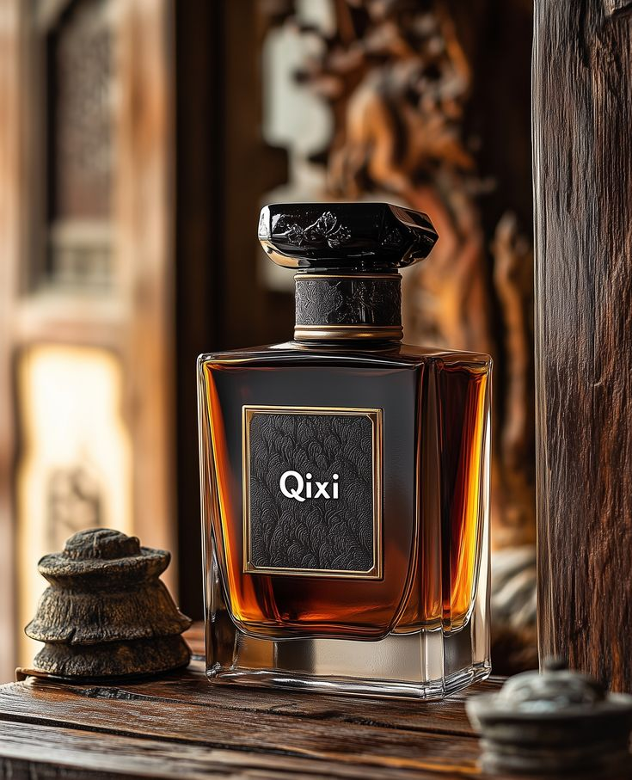
$119.99

Fragrance Description:
An intoxicating dark fragrance with blackcurrant, amber, and smoky vanilla for a mysterious allure.

Fragrance Notes:
Top Notes: Citrus, Floral Accents
Heart Notes: Jasmine, Peony, Amber
Base Notes: Musk, Vanilla, Sandalwood

Key Features:
• Elegant, long-lasting luxury scent
• Perfect for day or night wear
• Refined design and craftsmanship
• A blend of modern and classic sophistication

About the Brand:
Each luxury perfume represents artistry, emotion, and excellence — created for individuals who seek elegance, uniqueness, and unforgettable allure.
────────────────────────────

AZURE BLOOM
Price:
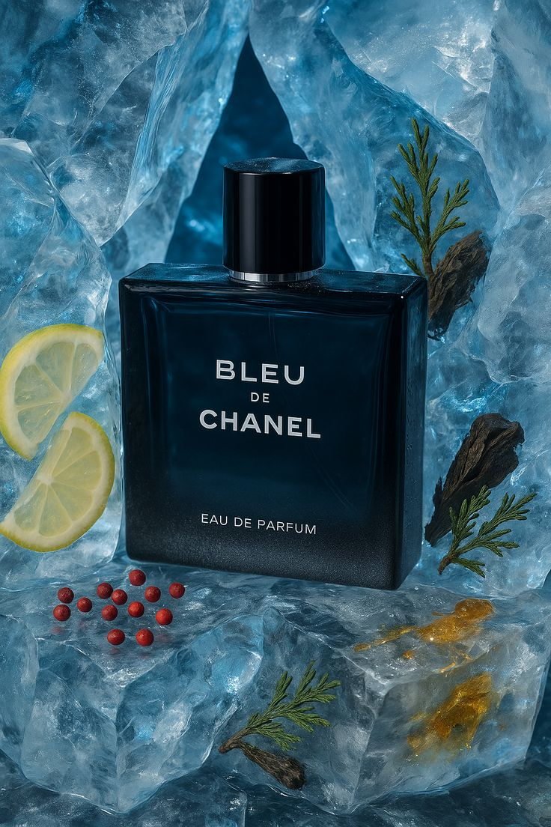
$125

Fragrance Description:
Fresh and breezy with aquatic florals and sea breeze accords inspired by ocean serenity.

Fragrance Notes:
Top Notes: Citrus, Floral Accents
Heart Notes: Jasmine, Peony, Amber
Base Notes: Musk, Vanilla, Sandalwood

Key Features:
• Elegant, long-lasting luxury scent
• Perfect for day or night wear
• Refined design and craftsmanship
• A blend of modern and classic sophistication

About the Brand:
Each luxury perfume represents artistry, emotion, and excellence — created for individuals who seek elegance, uniqueness, and unforgettable allure.
────────────────────────────

ROSE ELIXIR
Price:
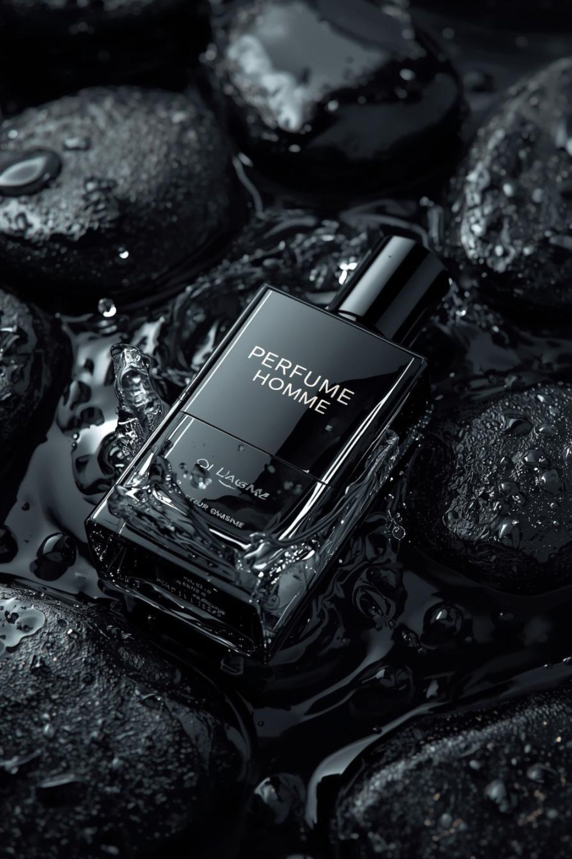
$109.99

Fragrance Description:
A luxurious floral potion combining rose petals, amber, and musk for a modern romantic touch.

Fragrance Notes:
Top Notes: Citrus, Floral Accents
Heart Notes: Jasmine, Peony, Amber
Base Notes: Musk, Vanilla, Sandalwood

Key Features:
• Elegant, long-lasting luxury scent
• Perfect for day or night wear
• Refined design and craftsmanship
• A blend of modern and classic sophistication

About the Brand:
Each luxury perfume represents artistry, emotion, and excellence — created for individuals who seek elegance, uniqueness, and unforgettable allure.
────────────────────────────

CITRUS CHARM
Price:
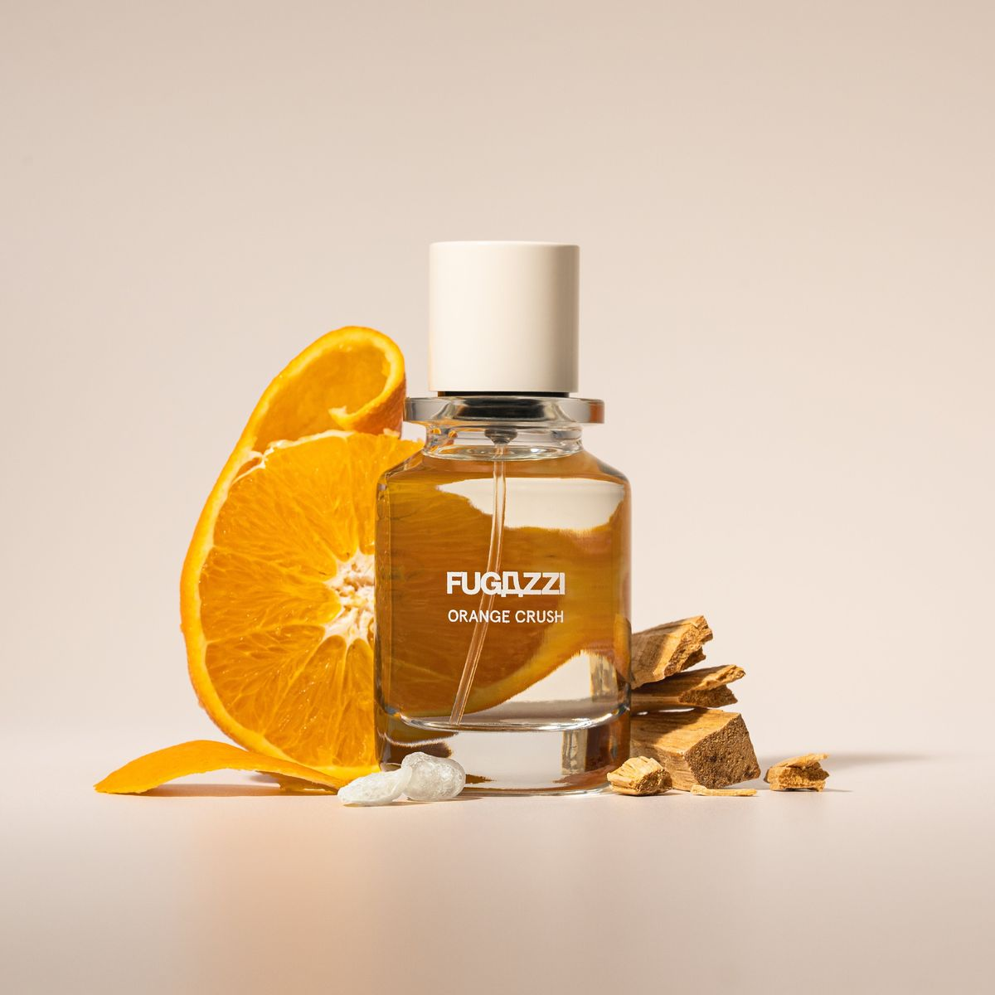
$89.99

Fragrance Description:
Bright and sparkling with lemon, orange blossom, and white musk — pure sunshine in a bottle.

Fragrance Notes:
Top Notes: Citrus, Floral Accents
Heart Notes: Jasmine, Peony, Amber
Base Notes: Musk, Vanilla, Sandalwood

Key Features:
• Elegant, long-lasting luxury scent
• Perfect for day or night wear
• Refined design and craftsmanship
• A blend of modern and classic sophistication

About the Brand:
Each luxury perfume represents artistry, emotion, and excellence — created for individuals who seek elegance, uniqueness, and unforgettable allure.
────────────────────────────

MIDNIGHT OUD
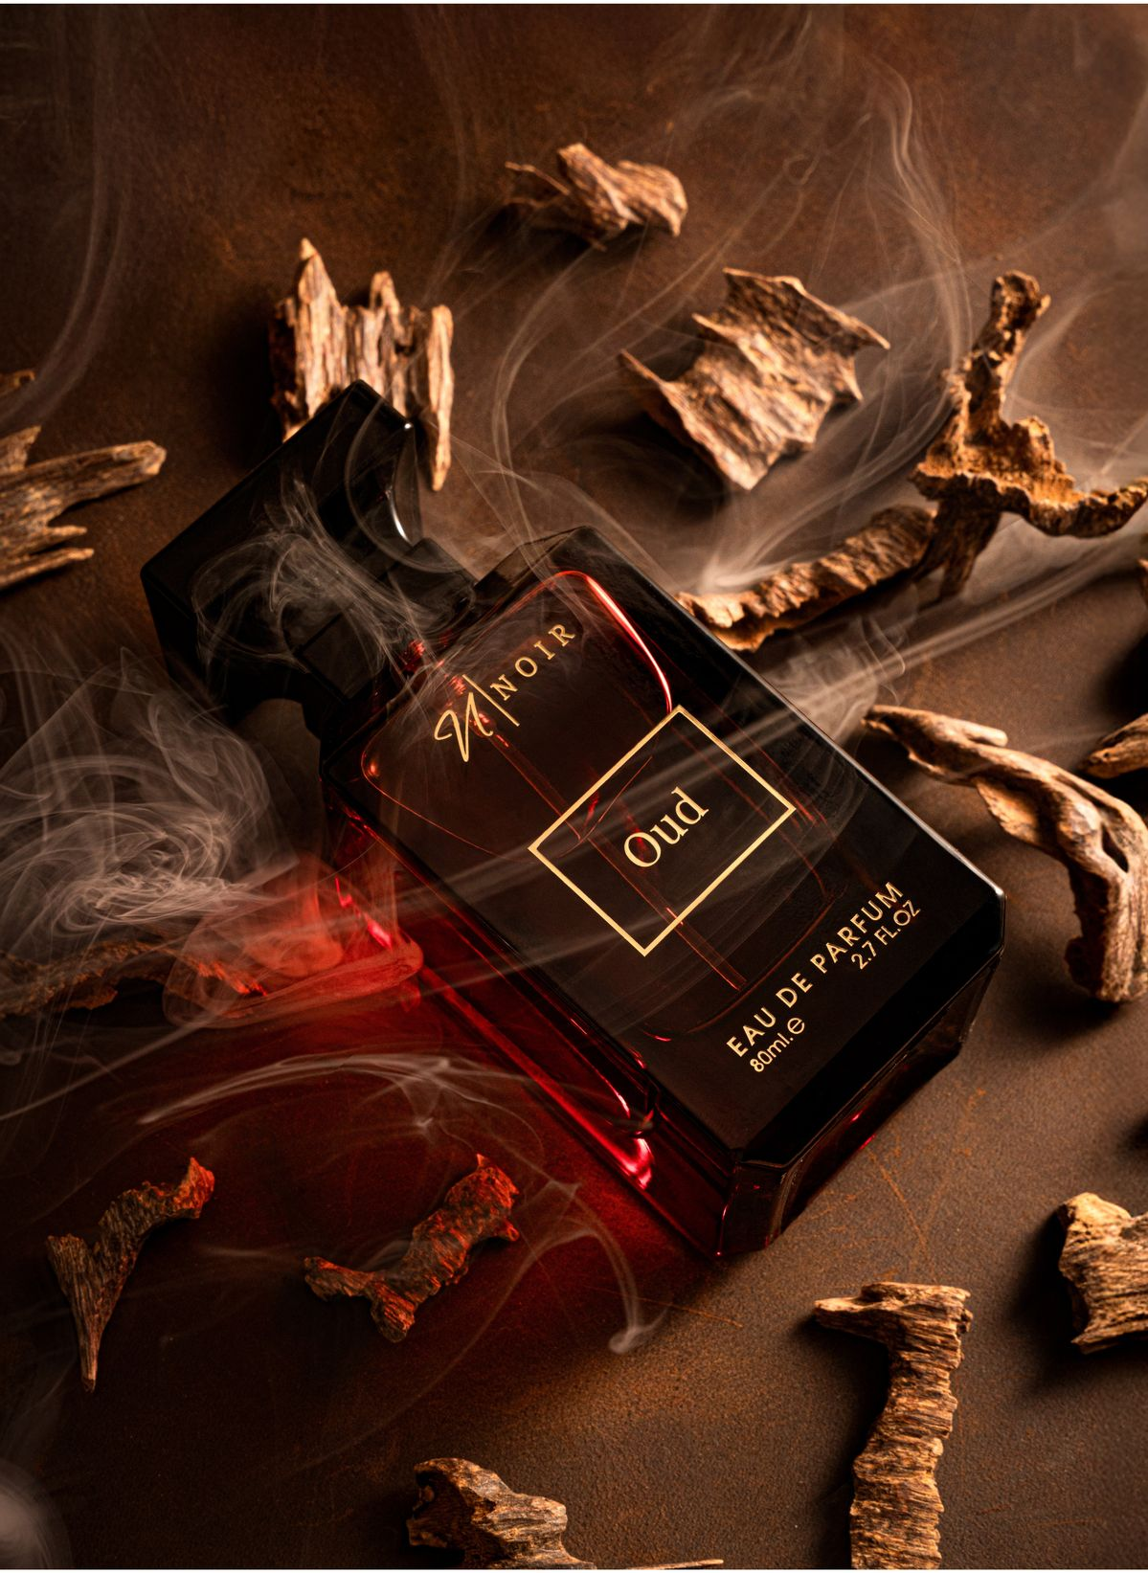
Price:
$139.99

Fragrance Description:
A luxurious oriental fragrance with spicy saffron and deep oud for evening sophistication.

Fragrance Notes:
Top Notes: Citrus, Floral Accents
Heart Notes: Jasmine, Peony, Amber
Base Notes: Musk, Vanilla, Sandalwood

Key Features:
• Elegant, long-lasting luxury scent
• Perfect for day or night wear
• Refined design and craftsmanship
• A blend of modern and classic sophistication

About the Brand:
Each luxury perfume represents artistry, emotion, and excellence — created for individuals who seek elegance, uniqueness, and unforgettable allure.
────────────────────────────

GREEN SERENITY

Price:
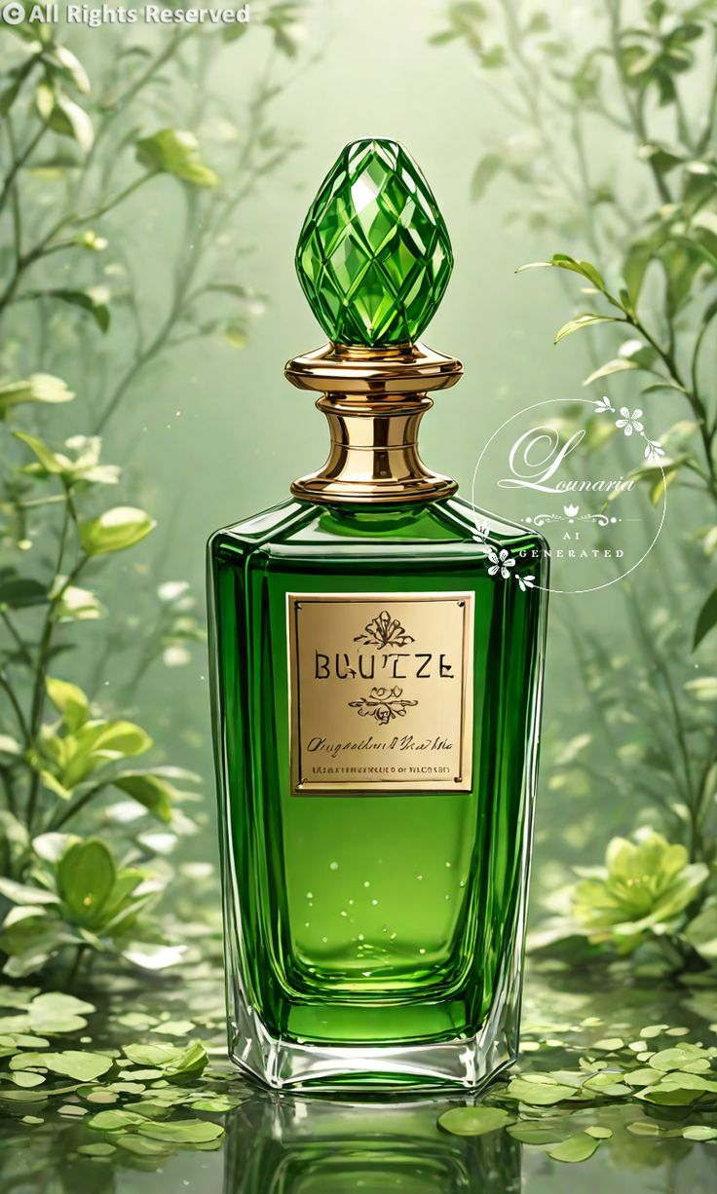
$89.99

Fragrance Description:
A calming green fragrance with notes of bamboo, citrus leaves, and soft white musk.

Fragrance Notes:
Top Notes: Citrus, Floral Accents
Heart Notes: Jasmine, Peony, Amber
Base Notes: Musk, Vanilla, Sandalwood

Key Features:
• Elegant, long-lasting luxury scent
• Perfect for day or night wear
• Refined design and craftsmanship
• A blend of modern and classic sophistication

About the Brand:
Each luxury perfume represents artistry, emotion, and excellence — created for individuals who seek elegance, uniqueness, and unforgettable allure.
────────────────────────────

CLOUD MIST
Price:
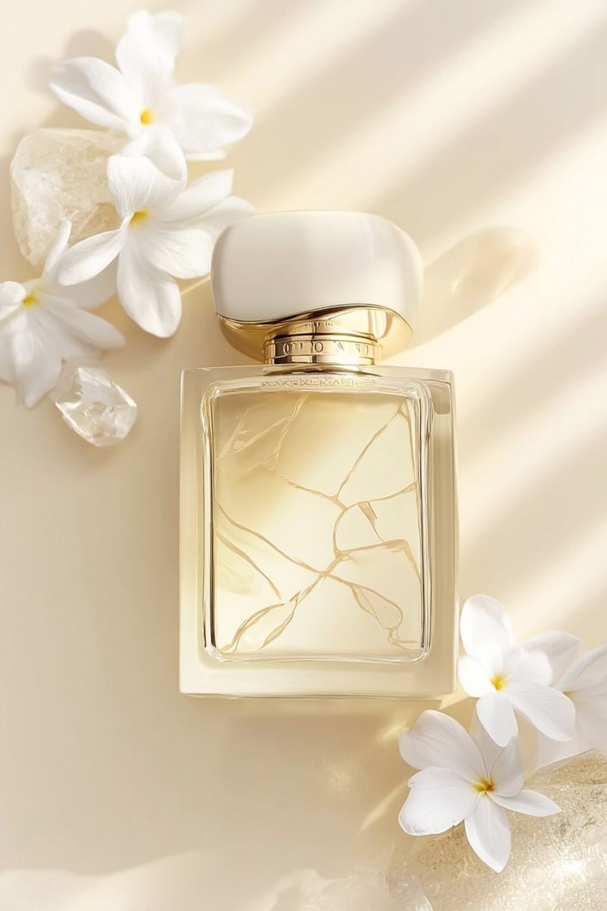
$94.99

Fragrance Description:
Light and dreamy, blending pear blossom, vanilla, and musk for a delicate aura.

Fragrance Notes:
Top Notes: Citrus, Floral Accents
Heart Notes: Jasmine, Peony, Amber
Base Notes: Musk, Vanilla, Sandalwood

Key Features:
• Elegant, long-lasting luxury scent
• Perfect for day or night wear
• Refined design and craftsmanship
• A blend of modern and classic sophistication

About the Brand:
Each luxury perfume represents artistry, emotion, and excellence — created for individuals who seek elegance, uniqueness, and unforgettable allure.
────────────────────────────

ROYAL ESSENCE
Price:
$149.99

Fragrance Description:
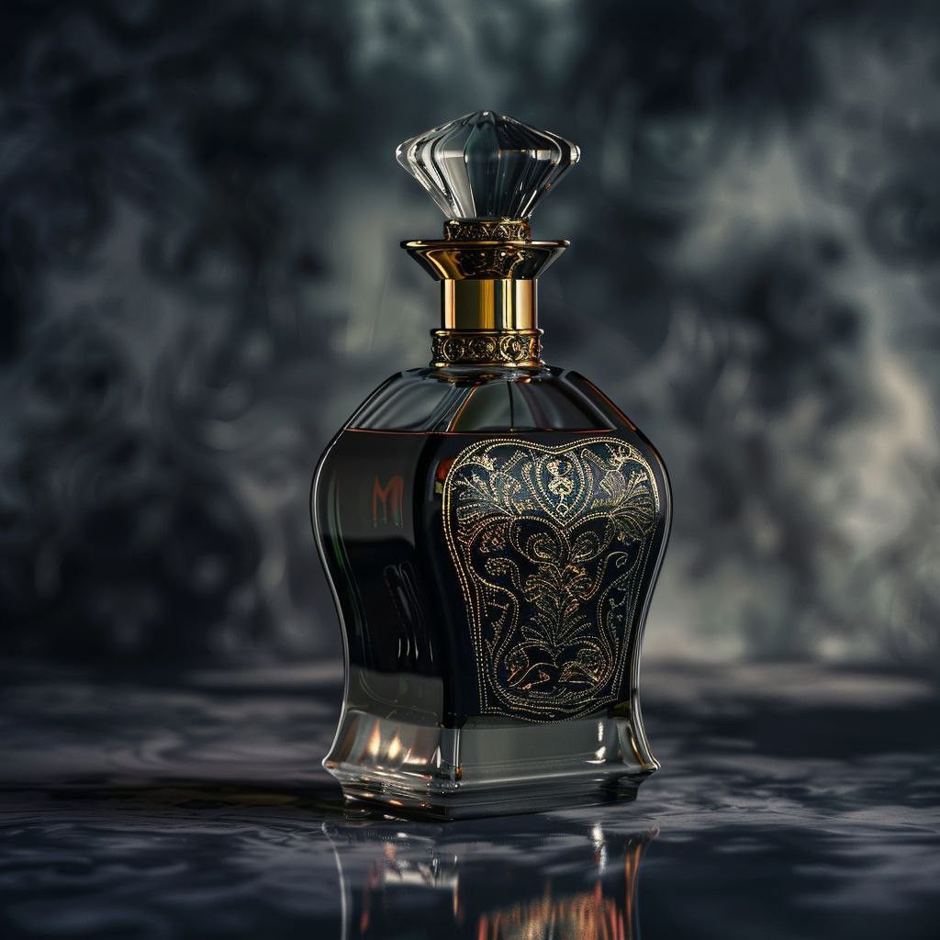
Majestic and refined with amber, tonka bean, and sandalwood representing noble grace.

Fragrance Notes:
Top Notes: Citrus, Floral Accents
Heart Notes: Jasmine, Peony, Amber
Base Notes: Musk, Vanilla, Sandalwood

Key Features:
• Elegant, long-lasting luxury scent
• Perfect for day or night wear
• Refined design and craftsmanship
• A blend of modern and classic sophistication

About the Brand:
Each luxury perfume represents artistry, emotion, and excellence — created for individuals who seek elegance, uniqueness, and unforgettable allure.
────────────────────────────

GOLDEN DESIRE
Price:
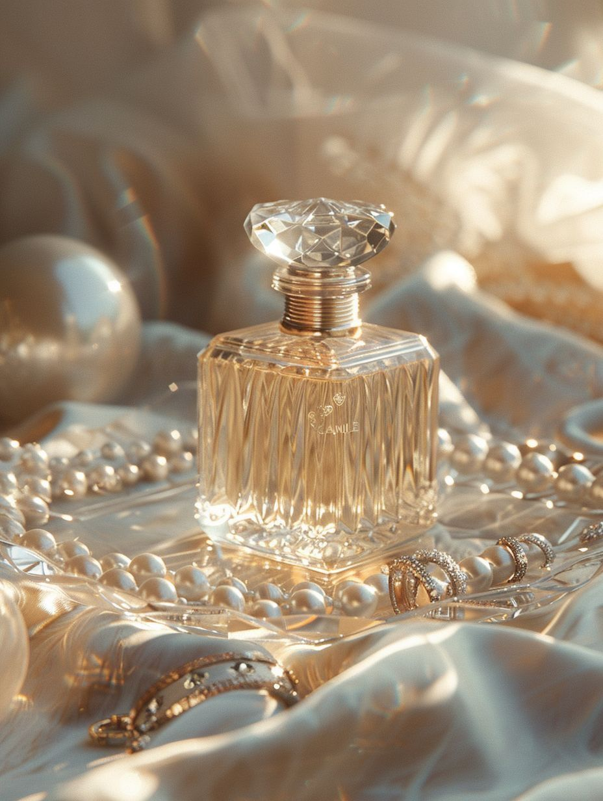
$129.99

Fragrance Description:
A warm and seductive scent with honeyed amber, rose, and patchouli.

Fragrance Notes:
Top Notes: Citrus, Floral Accents
Heart Notes: Jasmine, Peony, Amber
Base Notes: Musk, Vanilla, Sandalwood

Key Features:
• Elegant, long-lasting luxury scent
• Perfect for day or night wear
• Refined design and craftsmanship
• A blend of modern and classic sophistication

About the Brand:
Each luxury perfume represents artistry, emotion, and excellence — created for individuals who seek elegance, uniqueness, and unforgettable allure.
────────────────────────────

LOST CHERRY

Price:
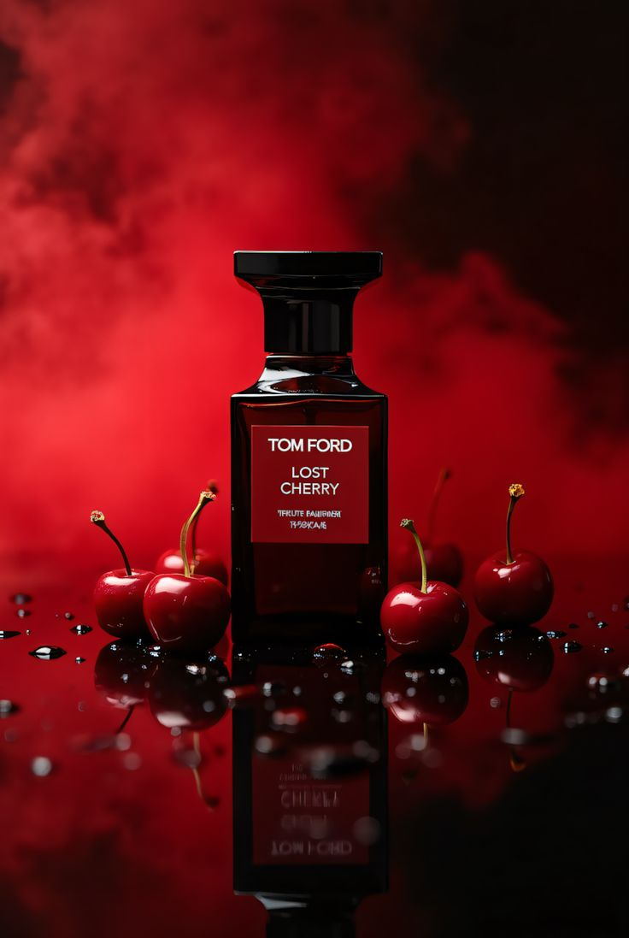
$150

Fragrance Description:
Sweet and provocative with black cherry, almond, and Turkish rose — irresistibly bold.

Fragrance Notes:
Top Notes: Citrus, Floral Accents
Heart Notes: Jasmine, Peony, Amber
Base Notes: Musk, Vanilla, Sandalwood

Key Features:
• Elegant, long-lasting luxury scent
• Perfect for day or night wear
• Refined design and craftsmanship
• A blend of modern and classic sophistication

About the Brand:
Each luxury perfume represents artistry, emotion, and excellence — created for individuals who seek elegance, uniqueness, and unforgettable allure.
────────────────────────────

