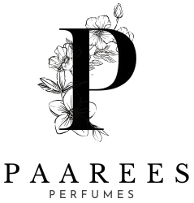

DIOR PERFUME COLLECTION AND DESCRIPTION

DIOR PERFUME
The Art Of Timeless Elegance
Dior is more than a fragrance — it’s a legacy of French sophistication and modern grace. Each perfume tells a story of beauty, confidence, and power. From the magnetic charm of Sauvage to the romantic bloom of J’adore, Dior captures emotions in every drop. Its perfumes celebrate individuality — bold, elegant, and unforgettable — just like the people who wear them.

Contents
Davidoff Perfume Collection 3
DIOR SAUVAGE 3
Fragrance Type: 3
Fragrance Description: 3
Fragrance Notes 3
Key Features 3
Usage Tips 3
About the Brand 3
Dior J’adore 4
Fragrance Type: 4
Fragrance Description 4
Fragrance Notes 4
Key Features 4
Usage Tips 4
About the Brand 4
Dior Addict 5
Fragrance Type: 5
Fragrance Description 5
Fragrance Notes 5
Key Features 5
Usage Tips 5
About the Brand 5
Dior Homme 6
Fragrance Type: 6
Fragrance Description 6
Fragrance Notes 6
Key Features 6
Usage Tips 6
About the Brand 6
Miss Dior 7
Fragrance Type: 7
Fragrance Description 7
Fragrance Notes 7
Key Features 7
Usage Tips 7
About the Brand 7
Dior Poison 8
Fragrance Type: 8
Fragrance Description 8
Fragrance Notes 8
Key Features 8
Usage Tips 8
About the Brand 8

Davidoff Perfume Collection

DIOR SAUVAGE

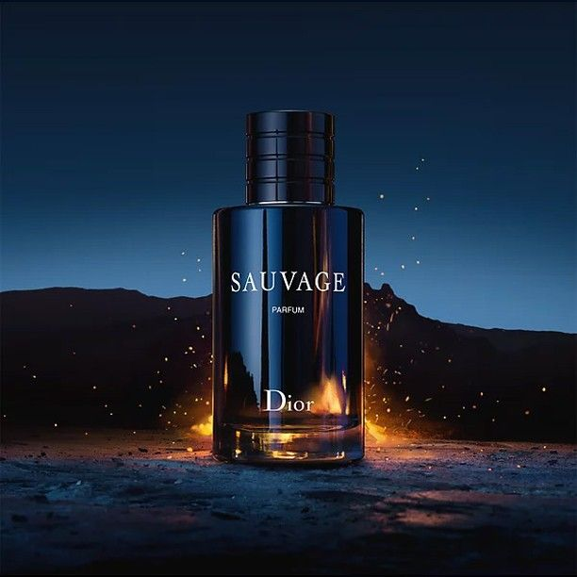
Fragrance Type:
Strong long-lasting perfume
Price: $160.00

Fragrance Description:
A bold, magnetic fragrance inspired by open landscapes and raw elegance. Opens with fresh bergamot and spicy Sichuan pepper, settling into woody amber and musk. Symbolizes masculine confidence and sophistication.

Fragrance Notes
Top Notes: Calabrian Bergamot, Sichuan Pepper
Heart Notes: Lavender, Star Anise, Nutmeg
Base Notes: Ambroxan, Cedarwood, Vanilla

Key Features
• Long-lasting projection
• Modern and masculine
• Iconic bottle design
• Perfect for day or night

Usage Tips
Spray on wrists, neck, and behind ears for a long-lasting scent trail.

About the Brand
Christian Dior represents timeless French craftsmanship and luxury. Each fragrance embodies elegance, passion, and individuality.

Dior J’adore

Fragrance Type:
Elegant floral perfume
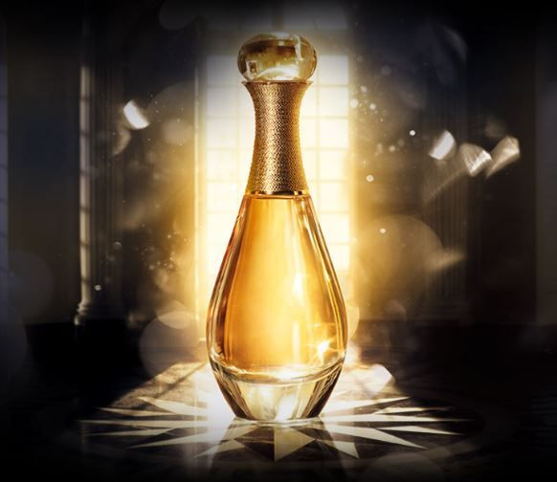
Price: $155.00

Fragrance Description
An icon of femininity, J’adore is a radiant floral bouquet that celebrates the beauty of women. It blends jasmine, rose, and ylang-ylang with a sensual fruity undertone.

Fragrance Notes
Top Notes: Ylang-Ylang, Mandarin, Peach
Heart Notes: Jasmine, Rose, Lily-of-the-Valley
Base Notes: Vanilla, Musk, Cedar

Key Features
• Elegant and graceful
• Perfect for special occasions
• Symbol of modern femininity

Usage Tips
Apply on pulse points for a luxurious floral trail.

About the Brand
J’adore captures Dior’s devotion to celebrating feminine beauty and luxury craftsmanship.
___________________________

Dior Addict

Fragrance Type:
Deep and sensual perfume
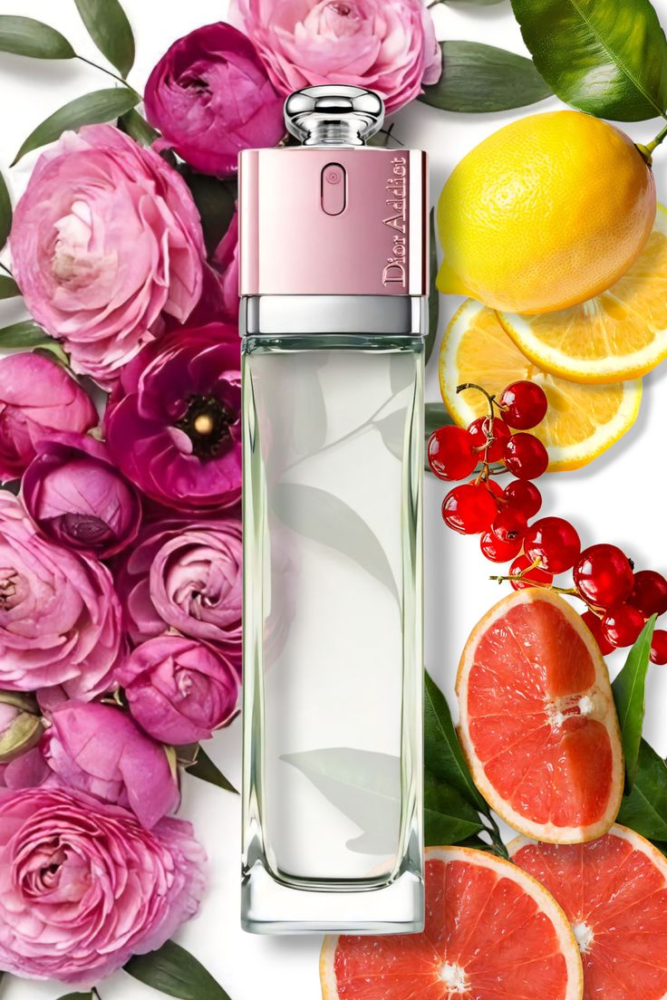
Price: $150.00

Fragrance Description
A sensual, addictive fragrance with notes of vanilla and tonka bean. It radiates warmth and sophistication, ideal for confident women who embrace their individuality.

Fragrance Notes
Top Notes: Mandarin Leaf, Orange Blossom
Heart Notes: Jasmine Sambac, Rose
Base Notes: Vanilla, Sandalwood, Tonka Bean

Key Features
• Warm and sensual
• Long-lasting fragrance
• Ideal for evening wear

Usage Tips
Spray lightly on pulse points for an alluring scent.

About the Brand
Dior Addict is a tribute to bold women who express confidence and freedom.
___________________________

Dior Homme

Fragrance Type:
Fresh and masculine scent
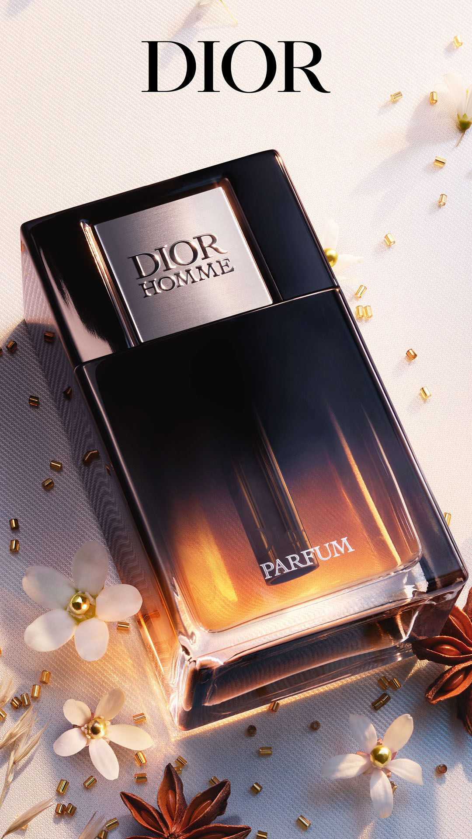
Price: $145.00

Fragrance Description
Dior Homme is refined and modern, blending iris and vetiver with amber and leather. A symbol of understated elegance for men.

Fragrance Notes
Top Notes: Lavender, Sage, Cardamom
Heart Notes: Iris, Cocoa, Amber
Base Notes: Vetiver, Leather, Patchouli

Key Features
• Sophisticated and fresh
• Perfect balance of wood and floral
• Versatile for daily wear

Usage Tips
Use daily after showering for a clean, confident scent.

About the Brand
Dior Homme redefines masculinity with a blend of sophistication and modernity.
____________________________________

Miss Dior

Fragrance Type:
Romantic floral perfume
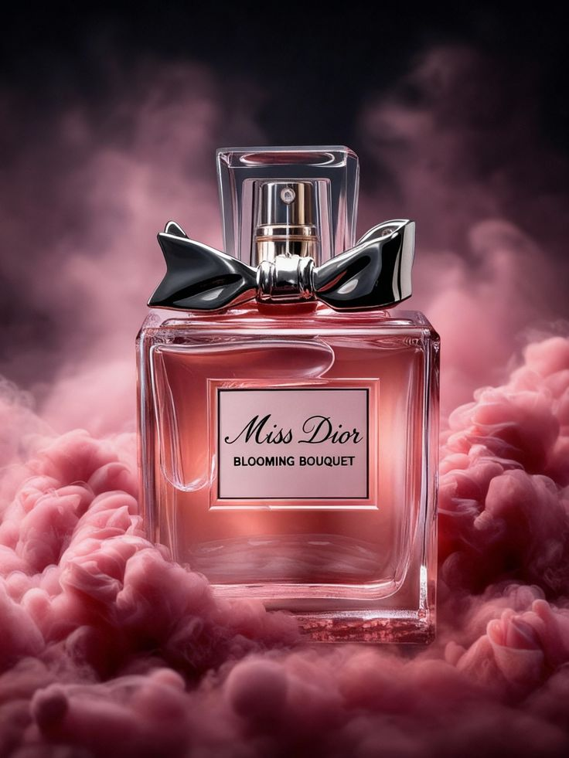
Price: $155.00

Fragrance Description
A romantic and youthful fragrance with floral heart and a touch of patchouli. It embodies the essence of love and elegance.

Fragrance Notes
Top Notes: Blood Orange, Mandarin
Heart Notes: Grasse Rose, Jasmine
Base Notes: Patchouli, Musk, Amber

Key Features
• Romantic and youthful
• Elegant and bright
• Signature Dior femininity

Usage Tips
Apply to neck and wrists to reveal its romantic notes.

About the Brand
Miss Dior celebrates youthful energy and the beauty of modern romance.
________________________________

Dior Poison

Fragrance Type:
Strong and rich evening perfume
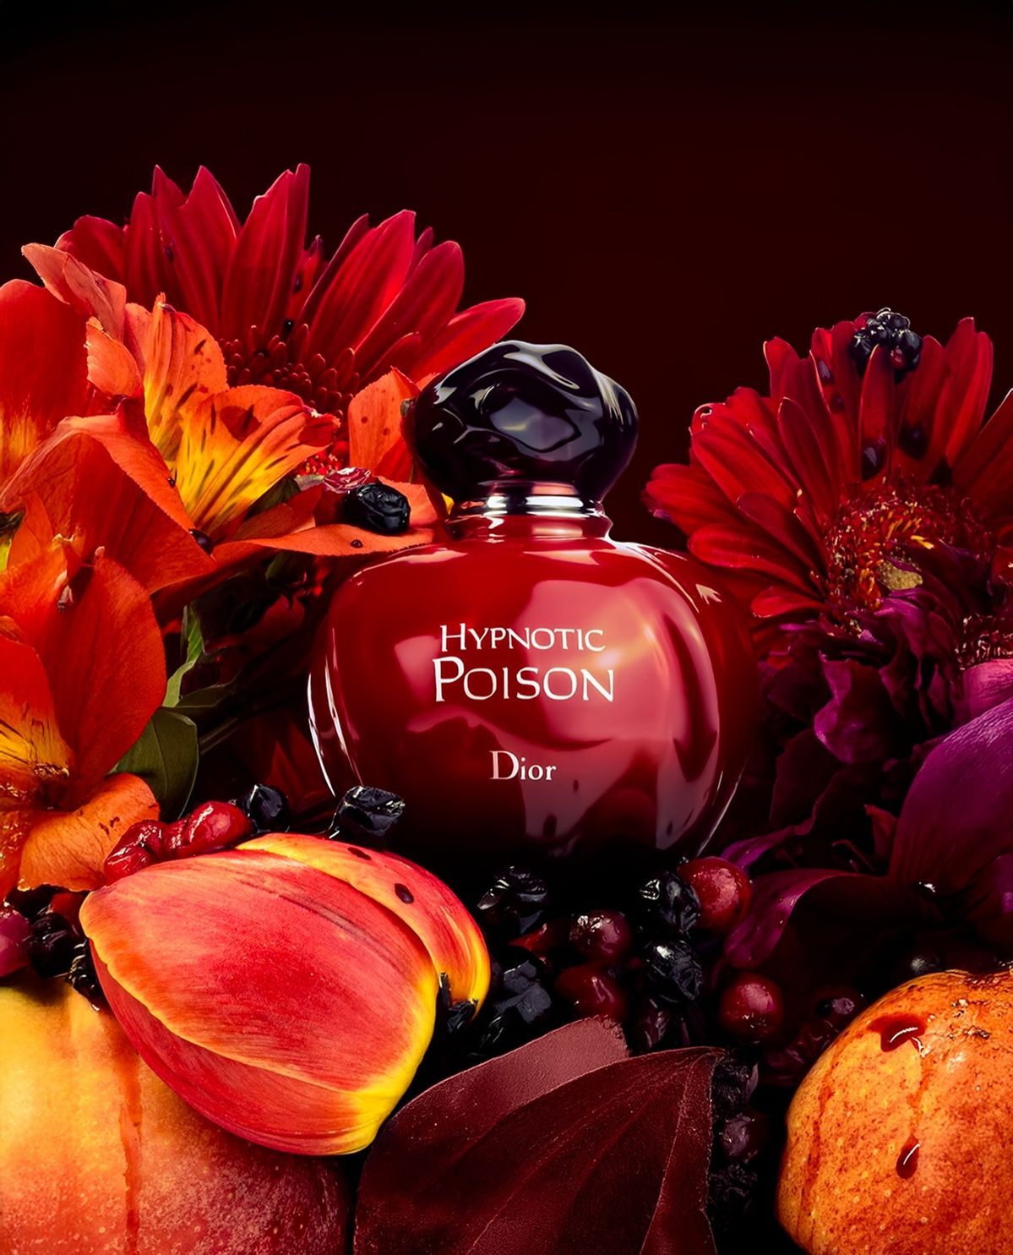
Price: $160.00

Fragrance Description
Mysterious and seductive, Poison is an unforgettable oriental floral scent blending tuberose, amber, and honey. It’s bold, confident, and timeless.

Fragrance Notes
Top Notes: Coriander, Wild Berries, Plum
Heart Notes: Tuberose, Jasmine, Rose
Base Notes: Amber, Honey, Musk

Key Features
• Intense and seductive
• Oriental floral masterpiece
• Long-lasting luxury scent

Usage Tips
Spray sparingly; its deep notes evolve beautifully through the day.

About the Brand
Poison embodies Dior’s daring creativity and passion for bold, captivating scents.
_____________________________________

