

DAVIDOFF PERFUME COLLECTION AND DESCRIPTION

DAVIDOFF PERFUME
The Spirit of Adventure
Davidoff fragrances are inspired by the energy of life — from ocean waves to mountain air. Each scent brings a refreshing sense of freedom, confidence, and exploration, perfect for those who dare to live boldly.

Contents
Davidoff Perfume Collection 3
3
DAVIDOFF CHAMPION 3
Fragrance Type: 3
Fragrance Description: 3
Fragrance Notes: 3
Key Features: 3
Usage Tips: 3
About the Brand: 3
COOL ELIXIR 4
Fragrance Type: 4
Fragrance Description: 4
Fragrance Notes: 4
Key Features: 4
Usage Tips: 4
About the Brand: 4
COOL WATER 5
Fragrance Type: 5
Fragrance Description: 5
Fragrance Notes: 5
Key Features: 5
Usage Tips: 5
About the Brand: 5
ZINO 6
Fragrance Type: 6
Fragrance Description: 6
Fragrance Notes: 6
Key Features: 6
Usage Tips: 6
About the Brand: 6
ADVENTURE 7
Fragrance Type: 7
Fragrance Description: 7
Fragrance Notes: 7
Key Features: 7
Usage Tips: 7
About the Brand: 7
RUN WILD 8
Fragrance Type: 8
Fragrance Description: 8
Fragrance Notes: 8
Key Features: 8
Usage Tips: 8
About The Brand 8

Davidoff Perfume Collection
1

DAVIDOFF CHAMPION

Fragrance Type:
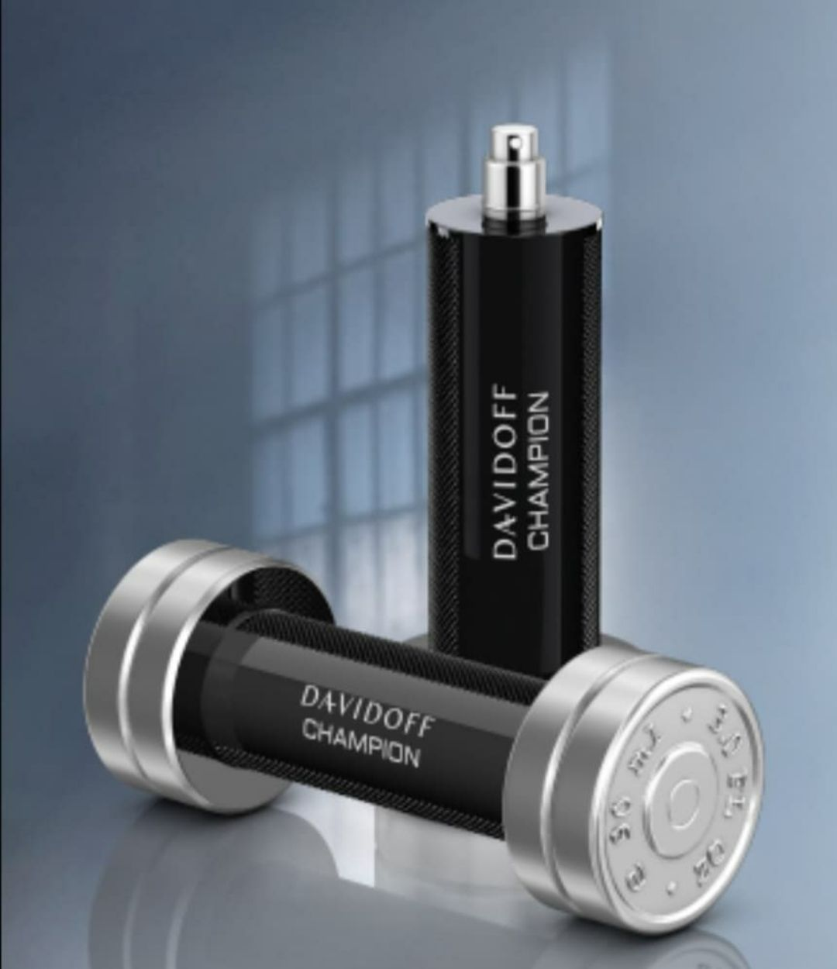
Sporty and energetic scent
Price: $100

Fragrance Description:
A bold fragrance celebrating victory, with citrus top notes and an energetic heart of galbanum and oak moss.

Fragrance Notes:
Top Notes: Citrus, Aromatic Herbs
Heart Notes: Spices, Floral Accents
Base Notes: Amber, Cedar, Sandalwood

Key Features:
• Energetic and refreshing compositions
• Perfect for outdoor and casual wear
• Distinct masculine identity
• Excellent longevity

Usage Tips:
Apply before workouts or outdoor events.

About the Brand:
Davidoff embodies adventure, elegance, and vitality. Each fragrance is crafted to inspire confidence, energy, and sophistication for modern men.
────────────────────────────

2

COOL ELIXIR

Fragrance Type:
Refreshing and cool perfume
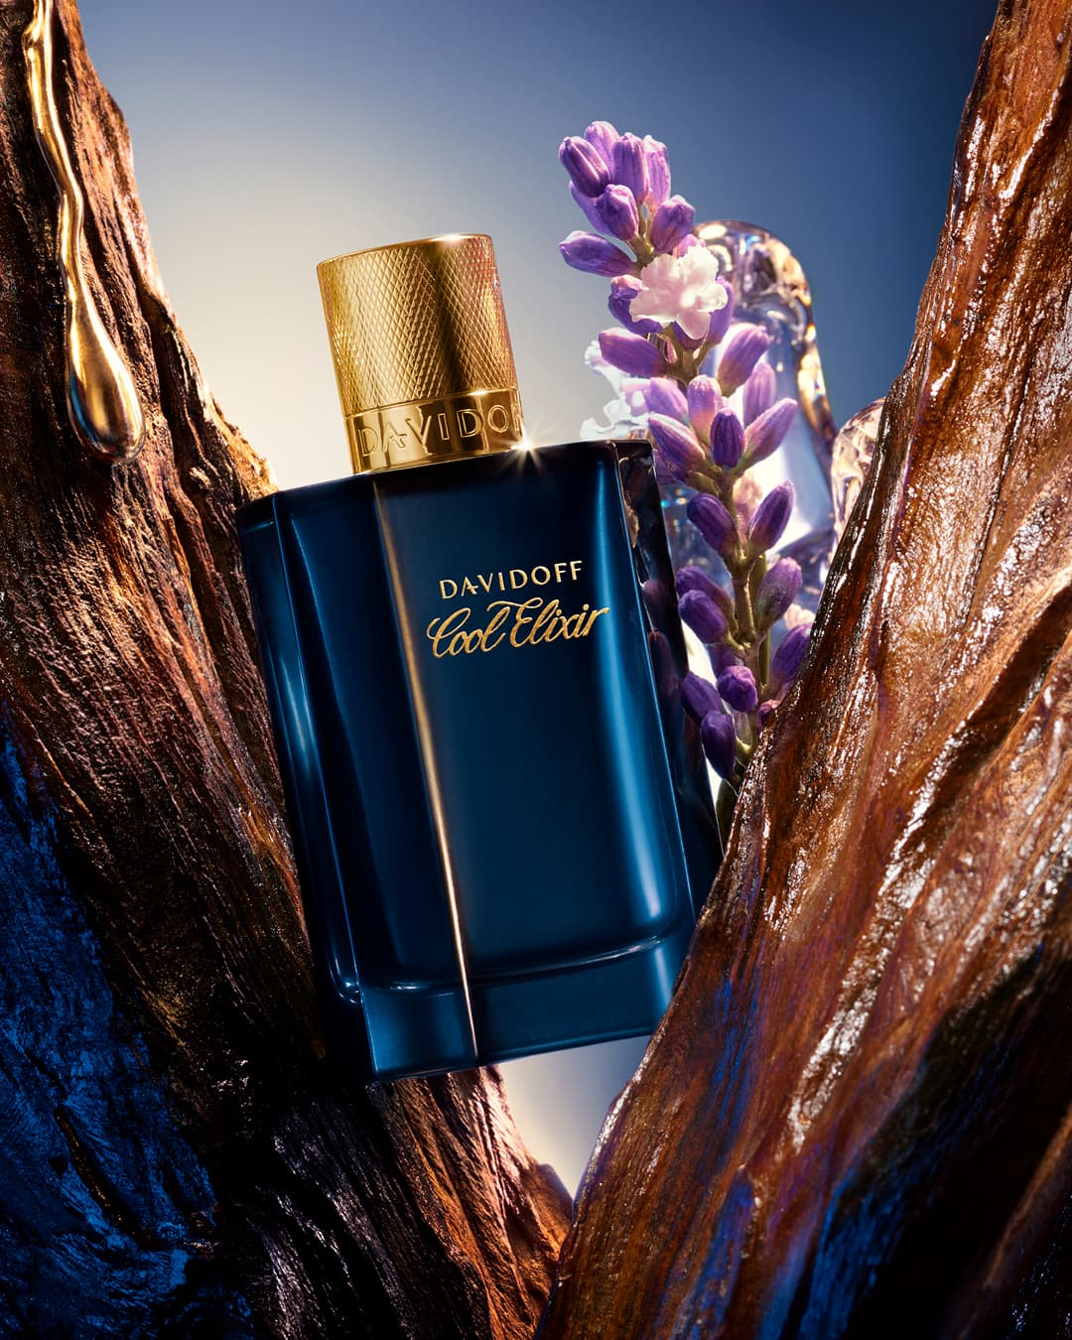
Price: $88

Fragrance Description:
A refreshing aquatic scent inspired by ocean waves, blending citrus zest with cool amber and marine accords.

Fragrance Notes:
Top Notes: Citrus, Aromatic Herbs
Heart Notes: Spices, Floral Accents
Base Notes: Amber, Cedar, Sandalwood

Key Features:
• Energetic and refreshing compositions
• Perfect for outdoor and casual wear
• Distinct masculine identity
• Excellent longevity

Usage Tips:
Spray on wrists and neck during hot days.

About the Brand:
Davidoff embodies adventure, elegance, and vitality. Each fragrance is crafted to inspire confidence, energy, and sophistication for modern men.
────────────────────────────

COOL WATER
3

Fragrance Type:
Fresh ocean-style scent
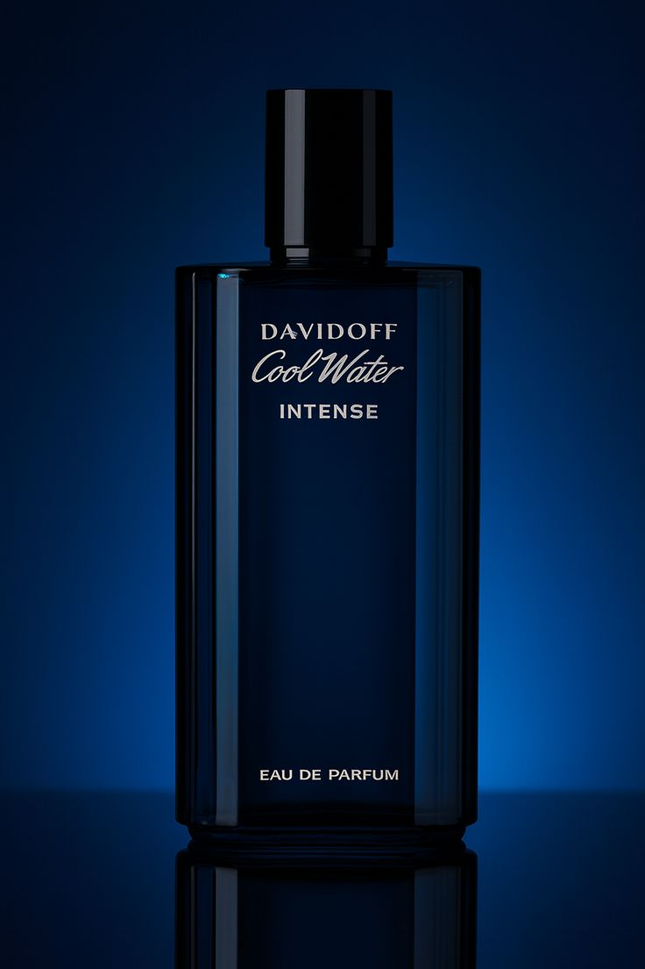
Price: $125

Fragrance Description:
An iconic fragrance combining mint, lavender, and sandalwood to evoke freshness and masculine strength.

Fragrance Notes:
Top Notes: Citrus, Aromatic Herbs
Heart Notes: Spices, Floral Accents
Base Notes: Amber, Cedar, Sandalwood

Key Features:
• Energetic and refreshing compositions
• Perfect for outdoor and casual wear
• Distinct masculine identity
• Excellent longevity

Usage Tips:
Use after shower for a clean and cool feeling.

About the Brand:
Davidoff embodies adventure, elegance, and vitality. Each fragrance is crafted to inspire confidence, energy, and sophistication for modern men.
────────────────────────────

4

ZINO

Fragrance Type:
Deep woody scent
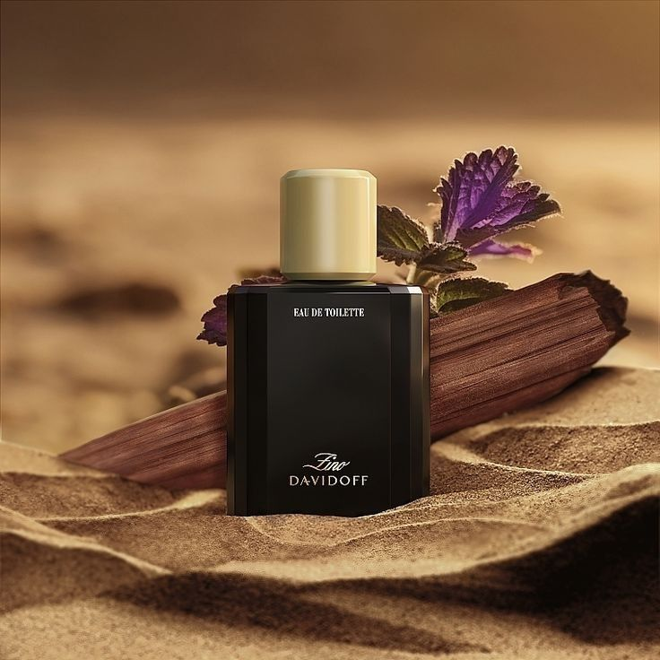
Price: $99

Fragrance Description:
Classic and intense, featuring bergamot, patchouli, and cedarwood that reflect timeless sophistication.

Fragrance Notes:
Top Notes: Citrus, Aromatic Herbs
Heart Notes: Spices, Floral Accents
Base Notes: Amber, Cedar, Sandalwood

Key Features:
• Energetic and refreshing compositions
• Perfect for outdoor and casual wear
• Distinct masculine identity
• Excellent longevity

Usage Tips:
Best for winter — spray lightly on chest and jacket.

About the Brand:
Davidoff embodies adventure, elegance, and vitality. Each fragrance is crafted to inspire confidence, energy, and sophistication for modern men.
────────────────────────────
5

ADVENTURE

Fragrance Type:
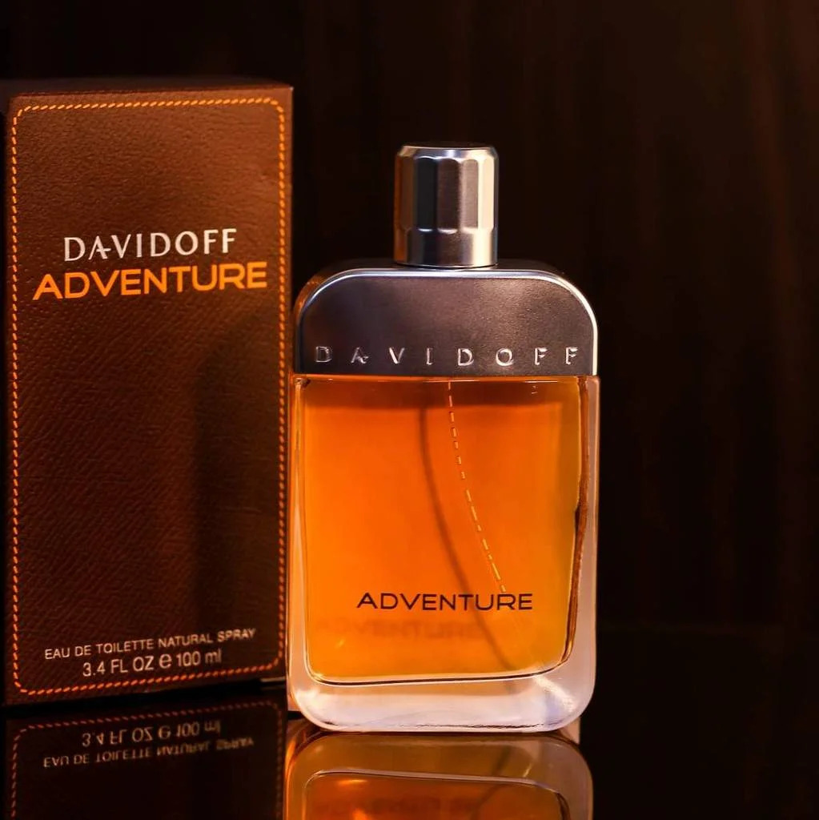
Fresh outdoor fragrance
Price: $85

Fragrance Description:
A daring and vibrant scent with spicy mandarin and sesame notes for the man who loves exploration.

Fragrance Notes:
Top Notes: Citrus, Aromatic Herbs
Heart Notes: Spices, Floral Accents
Base Notes: Amber, Cedar, Sandalwood

Key Features:
• Energetic and refreshing compositions
• Perfect for outdoor and casual wear
• Distinct masculine identity
• Excellent longevity

Usage Tips:
Apply on pulse points before travel or morning routines.

About the Brand:
Davidoff embodies adventure, elegance, and vitality. Each fragrance is crafted to inspire confidence, energy, and sophistication for modern men.
────────────────────────────

6

RUN WILD

Fragrance Type:
Strong masculine perfume
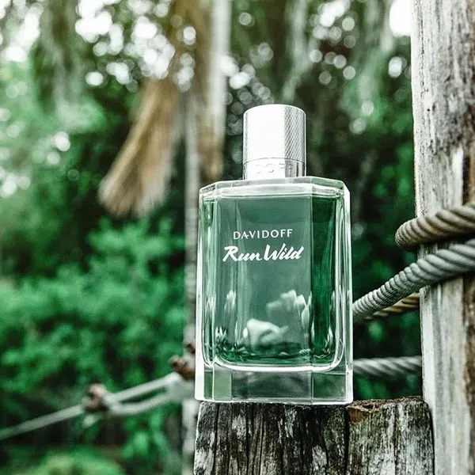
Price: $135

Fragrance Description:
A spirited blend of ginger, cinnamon, and fir balsam — symbolizing freedom and power of nature.

Fragrance Notes:
Top Notes: Citrus, Aromatic Herbs
Heart Notes: Spices, Floral Accents
Base Notes: Amber, Cedar, Sandalwood

Key Features:
• Energetic and refreshing compositions
• Perfect for outdoor and casual wear
• Distinct masculine identity
• Excellent longevity

Usage Tips:
Spray on wrists and behind neck for long-lasting power.

About The Brand
Davidoff embodies adventure, elegance, and vitality. Each fragrance is crafted to inspire confidence, energy, and sophistication for modern men.
────────────────────────────

