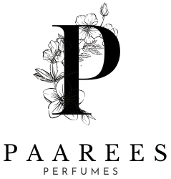
Calvin Klein (CK) Perfume

The Modern Minimalist
Calvin Klein defines modern sophistication with simplicity and boldness. CK perfumes blend freshness and sensuality, creating fragrances that feel effortlessly stylish and unisex — a true reflection of contemporary spirit.

CALVIN KLEIN PERFUME COLLECTION AND DESCRIPTION

Contents
The Modern Minimalist 1
Calvin Klein Perfume Collection 4
CK ETERNITY 4
Fragrance Type 4
Fragrance Description 4
Fragrance Notes 4
Key Features 4
Usage Tips 4
About The Brand 4
CK IN2U 5
Fragrance Type 5
Fragrance Description 5
Fragrance Notes 5
Key Features 5
Usage Tips 5
About the Brand 5
CK OBSESSION 6
Fragrance Type 6
Fragrance Description 6
Fragrance Notes: 6
Key Features: 6
Usage Tips 6
About the Brand: 6
CK ONE 7
Fragrance Type 7
Fragrance Description 7
Fragrance Notes: 7
Key Features: 7
Usage Tips 7
About the Brand: 7
Fragrance Type 8
Fragrance Description 8
Fragrance Notes: 8
Key Features: 8
Usage Tips 8
About the Brand: 8
CK SHOCK 9
Fragrance Type 9
Fragrance Description 9
Fragrance Notes: 9
Key Features: 9
Usage Tips 9
About the Brand: 9

Calvin Klein Perfume Collection

CK ETERNITY
1

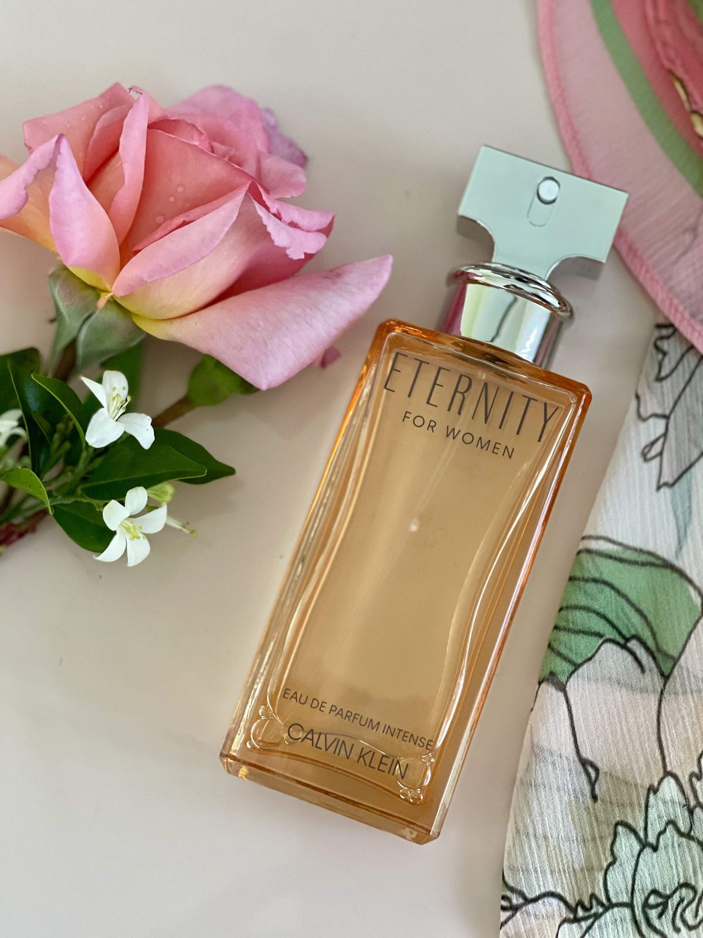
Fragrance Type
Classic romantic perfume
Price : $139

Fragrance Description
A timeless fragrance that blends floral and spicy notes with a base of sandalwood and amber for lasting elegance.

Fragrance Notes
Top Notes: Citrus, Floral Accents
Heart Notes: Jasmine, Lily, Spice
Base Notes: Musk, Amber, Cedarwood

Key Features
• Modern and timeless scent profile
• Long-lasting freshness
• Elegant bottle design
• Suitable for any occasion

Usage Tips
Spray on wrists and neck for daily freshness.

About The Brand
Calvin Klein is a pioneer in modern fragrance, known for minimalist yet expressive scents that reflect individuality, confidence, and timeless appeal.
────────────────────────────

CK IN2U
2

Fragrance Type
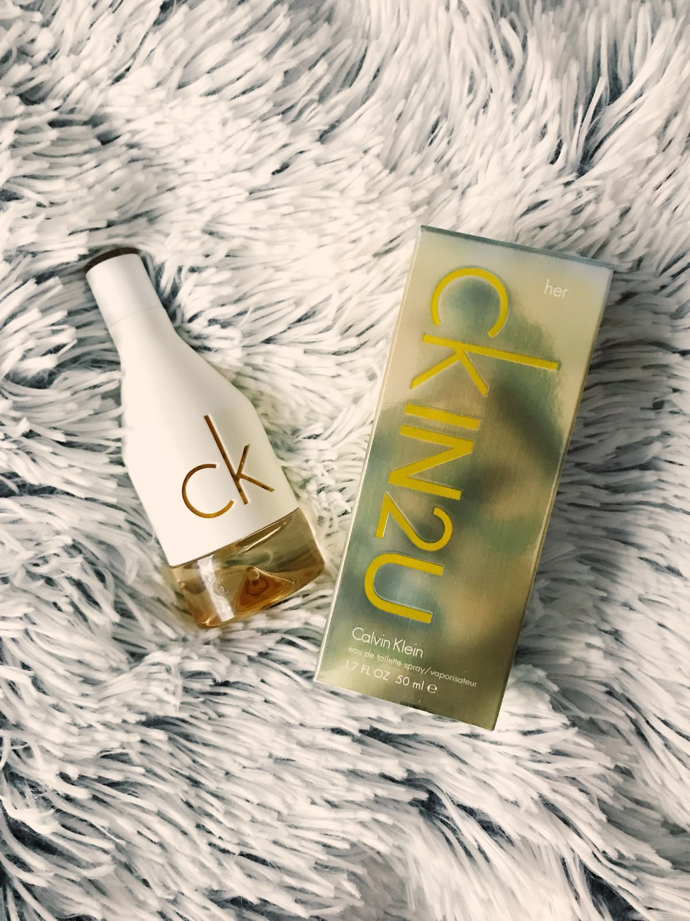
Youthful and energetic scent
Price: $110

Fragrance Description
A youthful and energetic scent featuring citrus and woody notes that evoke freedom and spontaneity.

Fragrance Notes
Top Notes: Citrus, Floral Accents
Heart Notes: Jasmine, Lily, Spice
Base Notes: Musk, Amber, Cedarwood

Key Features
• Modern and timeless scent profile
• Long-lasting freshness
• Elegant bottle design
• Suitable for any occasion

Usage Tips
Spray on chest and arms for a lively fragrance.

About the Brand
Calvin Klein is a pioneer in modern fragrance, known for minimalist yet expressive scents that reflect individuality, confidence, and timeless appeal.
────────────────────────────

CK OBSESSION
3

Fragrance Type
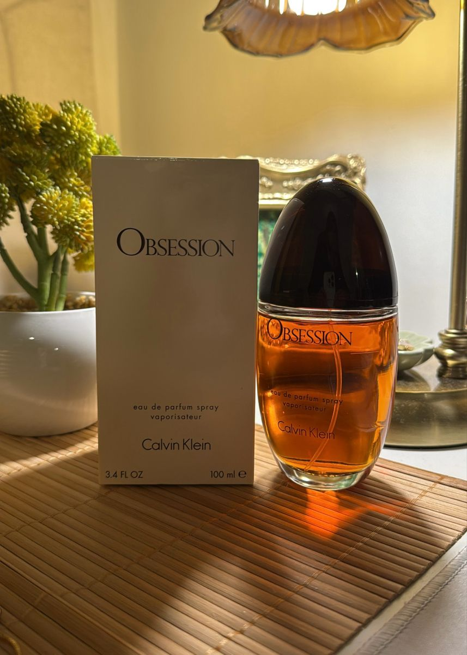
Warm and spicy perfume
Price: $99

Fragrance Description
Rich and sensual with spicy amber and vanilla tones that capture deep passion and allure.

Fragrance Notes:
Top Notes: Citrus, Floral Accents
Heart Notes: Jasmine, Lily, Spice
Base Notes: Musk, Amber, Cedarwood

Key Features:
• Modern and timeless scent profile
• Long-lasting freshness
• Elegant bottle design
• Suitable for any occasion

Usage Tips
Use one spray on wrists and collar for a lasting scent.

About the Brand:
Calvin Klein is a pioneer in modern fragrance, known for minimalist yet expressive scents that reflect individuality, confidence, and timeless appeal.
────────────────────────────

CK ONE
4

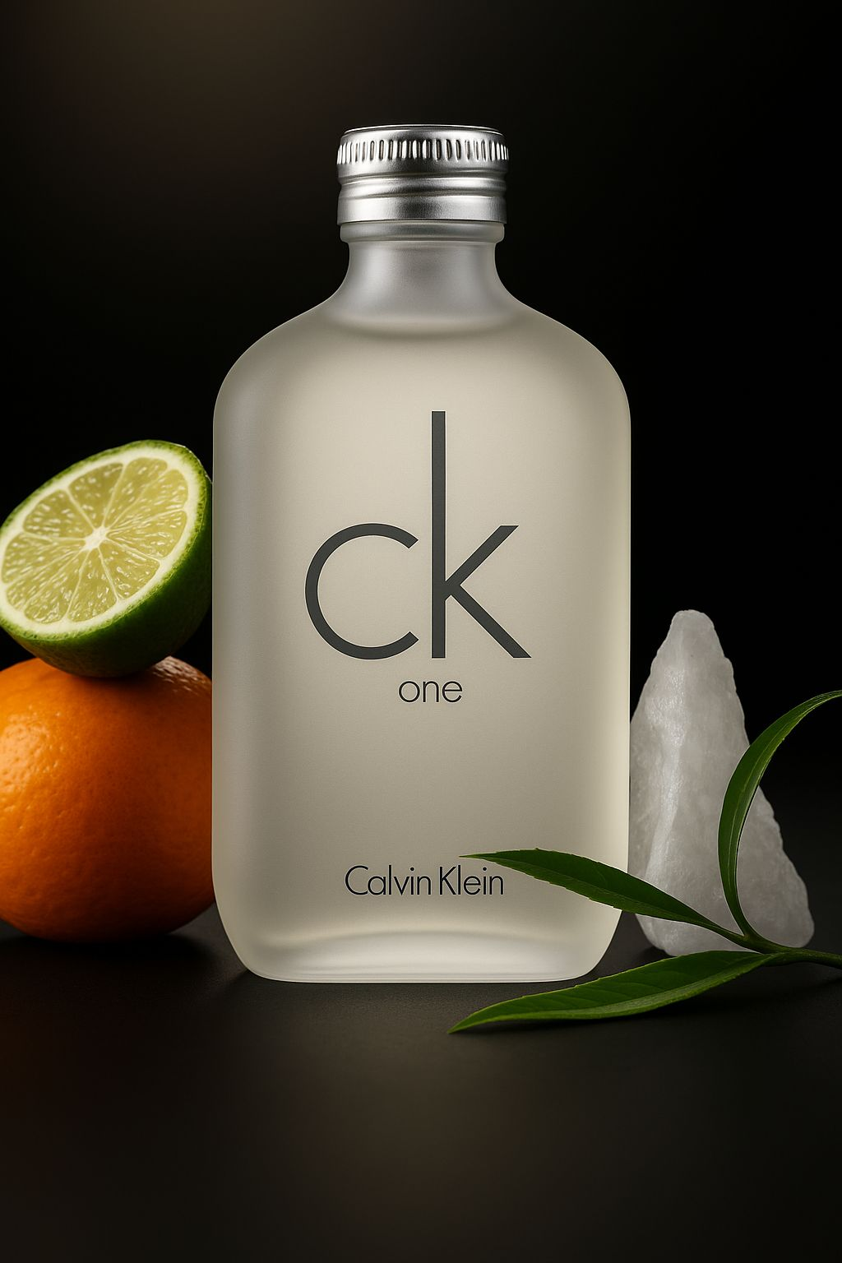
Fragrance Type
Clean unisex perfume (for men and women)
Price: $140

Fragrance Description
An iconic unisex fragrance offering fresh green tea, papaya, and musk for a clean, universal scent.

Fragrance Notes:
Top Notes: Citrus, Floral Accents
Heart Notes: Jasmine, Lily, Spice
Base Notes: Musk, Amber, Cedarwood

Key Features:
• Modern and timeless scent profile
• Long-lasting freshness
• Elegant bottle design
• Suitable for any occasion

Usage Tips
Spray on clothes or skin for a fresh citrus feel.

About the Brand:
Calvin Klein is a pioneer in modern fragrance, known for minimalist yet expressive scents that reflect individuality, confidence, and timeless appeal.
────────────────────────────
CK SHEER BEAUTY
5

Fragrance Type
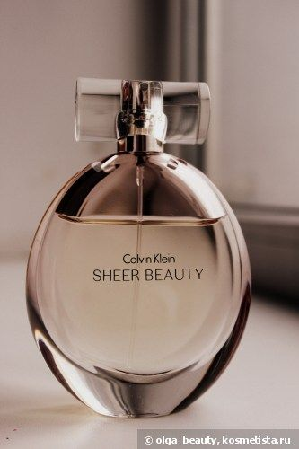
Soft and delicate floral scent
Price: $111

Fragrance Description
A soft, feminine fragrance with notes of peach blossom, jasmine, and pink lily symbolizing grace and confidence.

Fragrance Notes:
Top Notes: Citrus, Floral Accents
Heart Notes: Jasmine, Lily, Spice
Base Notes: Musk, Amber, Cedarwood

Key Features:
• Modern and timeless scent profile
• Long-lasting freshness
• Elegant bottle design
• Suitable for any occasion

Usage Tips
Apply on neck and inner arms for a gentle fragrance.

About the Brand:
Calvin Klein is a pioneer in modern fragrance, known for minimalist yet expressive scents that reflect individuality, confidence, and timeless appeal.
────────────────────────────

6

CK SHOCK

Fragrance Type
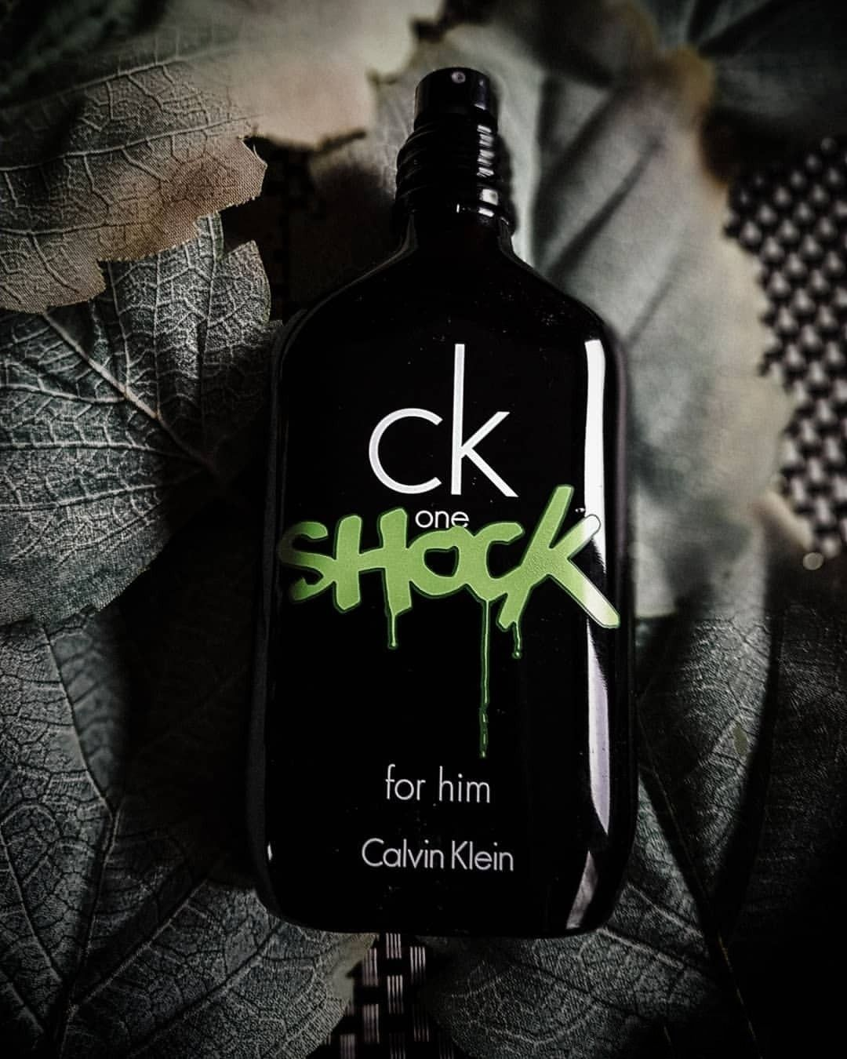
Bold and trendy perfume
Price: $120

Fragrance Description
A bold and edgy scent combining passionflower, blackberry, and amber for a daring, youthful vibe.

Fragrance Notes:
Top Notes: Citrus, Floral Accents
Heart Notes: Jasmine, Lily, Spice
Base Notes: Musk, Amber, Cedarwood

Key Features:
• Modern and timeless scent profile
• Long-lasting freshness
• Elegant bottle design
• Suitable for any occasion

Usage Tips
Best for night outs — spray on chest and wrists.

About the Brand:
Calvin Klein is a pioneer in modern fragrance, known for minimalist yet expressive scents that reflect individuality, confidence, and timeless appeal.
────────────────────────────

